**ERD OF LIBRARY MANAGEMENT SYSTEM**

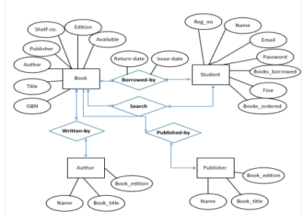

**CLASS DIAGRAM:**

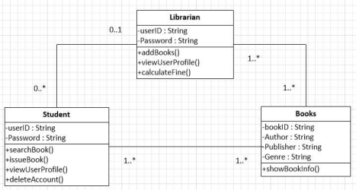

**SEQUENCE DIAGRAM:**

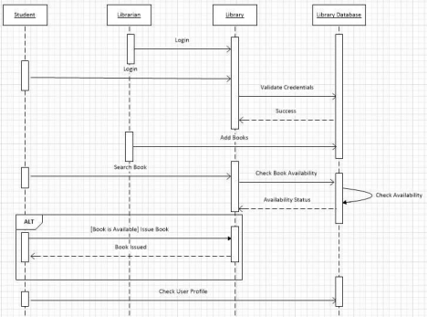**CONTEXT LEVEL:**

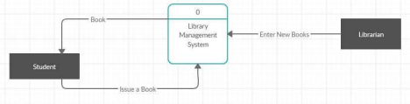**USE CASE DIAGRAM**

